**Advance Web Technology Assignment-1**

1. **Create a module named “calculator” using nodejs containing basic arithmetic functions such as addition, subtraction, division and multiplication. Perform arithmetic operations by importing the module. [CO1].**

**App.js**

const calculator = require('./calculator');

const sum = calculator.add(5, 3);

console.log(`Sum: ${sum}`);

const difference = calculator.subtract(8, 4);

console.log(`Difference: ${difference}`);

const product = calculator.multiply(2, 6);

console.log(`Product: ${product}`);

const quotient = calculator.divide(10, 2);

console.log(`Quotient: ${quotient}`);

**Calculator.js**

function add(a, b) {

return a + b;

}

function subtract(a, b) {

return a - b;

}

function multiply(a, b) {

return a * b;

}

function divide(a, b) {

if (b === 0) {

return "Cannot divide by zero";

}

return a / b;

}

module.exports = {

add,

subtract,

multiply,

divide

};

**Output:-**

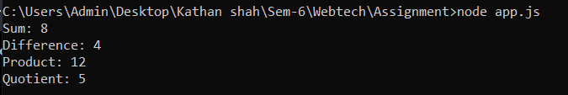

1. **Design a nodejs script to read a text file line by line and copy the contents of the text to another text file. [CO1].**

**App.js**

const fs = require('fs');

const readline = require('readline');

function copyFile(inputFilePath, outputFilePath) {

const inputStream = fs.createReadStream(inputFilePath);

const outputStream = fs.createWriteStream(outputFilePath);

const rl = readline.createInterface({

input: inputStream,

crlfDelay: Infinity

});

rl.on('line', (line) => {

outputStream.write(`${line}\n`);

});

rl.on('close', () => {

outputStream.end();

console.log('File copied successfully.');

});

}

const inputFilePath = 'input.txt';

const outputFilePath = 'output.txt';

copyFile(inputFilePath, outputFilePath);

**Input.txt**

This is line 1.

Here is the second line.

Node.js script will copy this text file line by line.

Each line will be written to the output file.

This is the last line.

**Output.txt**

This is line 1.

Here is the second line.

Node.js script will copy this text file line by line.

Each line will be written to the output file.

This is the last line.

**Output:-**



